Vietnam and its post-war Dynamics

I’ll like to share with readers some photos taken in the Vietnamese war Museum including graphic views of the devastation caused by the US during the Vietnamese war. These are Photos I took during a visit to the museum in “Saigon” or Ho Chi Mihn (HCM) city.

I also had the chance to take a boat ride in the Saigon River.

I was privileged to receive an invitation as an oral presenter during an international conference on Machine learning (ML) or Artificial Intelligence (AI) in HCM city. This was in December 2018.

The Vietnam-war pictures included in this article represent the tip of the iceberg, considering the copious and depressing number of casualties suffered during and after the war.

Indeed, poverty is ubiquitous, though on a positive note, I found crowds of happy, industrious and harmonious communities.

The reciprocal love between the Vietnamese and Americans remains live and well! For example, I met an American who stayed in the same hotel as I did. One morning during breakfast he expressed his attachment to Vietnam and confirmed by telling me he has been visiting the country every year in the last five years! And in one of several examples, one Vietnamese teenage student approached me to talk because he thought I was American. He was part of a college student tour shown in one of the photos. According to him, he had two interests: one was to improve his English and the other was to find out how to help vulnerable groups in his communities. In that regard, I shared some of my experience with and suggested different strategies that he could consider. We had barely started the conversation, when one of the students approached us with a cell phone and immediately started recording our conversation. Needless to say the other students who were curiously watching immediately joined and the conversation became more lively, exciting and inclusive. Everyone wanted to say something. Unfortunately, these sessions didn’t last for long as the boat was leaving soon and all the students had to get on board!

During the boat ride, the presence of gentrification was evident. Along the riverbanks, there was modern and recently constructed buildings with high rises that could easily compete with modern cities. And it was easy to conclude that these skyscrapers were a result of a relocation process during which the poor were either voluntarily or forcefully displaced: another indication gross and ubiquitous inequality!

The economic challenges not withstanding the communities continue to live to the fullest one day at a time!; an indication of how many have kept the war killings, devastations and dismemberment on the side! And yes, in general one gets a sense of forgiveness. The Vietnamese have come to make peace with the past, forgiven and never to forget.

One success story among others is the overwhelming number of motorbikes in the city. During one occasion, the Vietnamese soccer team defeated the Philippines in a soccer match. There was a city wide motor “bike carnival” that took place in the city even 24 hours after the victory. There seem to be more bikes than cars and the competition between both means of transportation is overwhelming. Pedestrians are at the mercy of motorbike riders. With the latter having no regards even for traffic lights. I had a chance to talk with one Vietnamese – an electronic engineer - who confirmed to me that even in Hanoi the capital, bikers are the rulers of the streets.

As of today, there are three major industrial and economic dynamics in the country - the motor bike industry, telecommunication and garment and textiles - all progressing and providing a source of compelling livelihood that continues to improve population quality of life!

For the future, I see a country that is upbeat, determined and resilient!

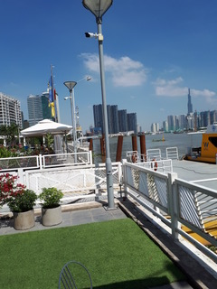
SAIGON RIVER EMBARKING SITE
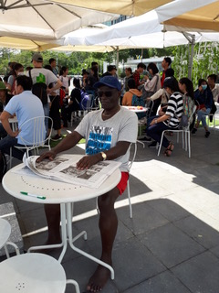
STUDENT PASENGERS WAITING TO EMBARK THE BOAT
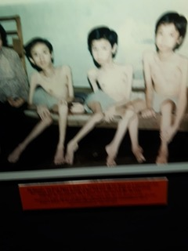
SOME VICTIMS OF THE VIETNAM WAR (VIETNAM MESEUM)

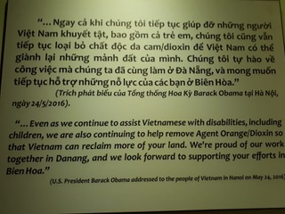
EXCERPTS OF PRESIDENT OBAMA'S SPEECH (VIETNAM MESEUM)

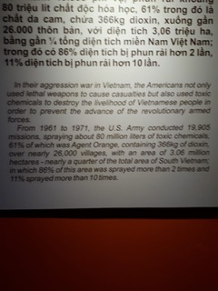
EXCERPT IN RECOGNITION OF AGENT ORANGE (VIETNAM MESEUM)

